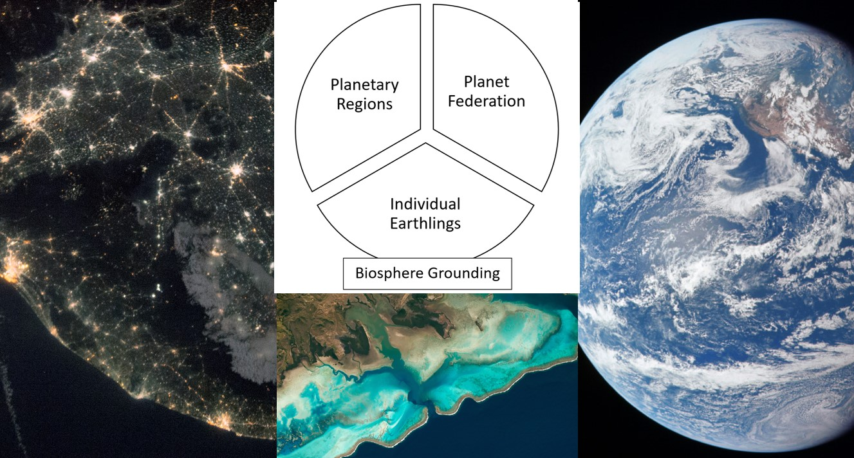

Planetary Federalism
Union-within the Biosphere-Now

Stefan Pedersen

Keywords: planetary, federalism, planet polity, biosphere, future visions, Clarence K. Streit.
Abstract: The structure of human civilization, most apparent in photos of the Earth at night, is federal in the sense that it is multicentric on the sub-state level. It is also situated within the Earth System. Planetary federalism is a means for us to recognize these core facets of reality and organize to adjust to the actual structure of human civilization – all while acknowledging that we inhabit our planetary reality as byproducts of the biosphere. We are part of life in the biosphere or we are nothing. Thinking of ourselves as a) individual Earthlings embedded in the biosphere, we can see that we all are situated in one or the other b) planetary region with its own urban/rural localities and ecology, and that c) a planet federation of all these regions now makes sense to ensure our survival as a civilized species. For in our age of anthropogenic global warming and ecocide a degree of universal coordination of our collective impact on the Earth has become a paramount task. The major obstacle to this rational and highly ecologically aware organization of human civilization is the outdated belief that nationalism has use-value for us.

Introduction
Will our present world order centered on the nation-state ever enable freedom for all individuals, universal justice and equality for humanity, and create a sustainable ecological balance between the long-term maintenance of the technosphere and a flourishing biosphere? The succinct answer to that question is “probably not.” So what is then the alternative? To understand what makes a good alternative to the current world order we have to grasp what is fundamentally at fault with the present arrangement. The answer is its inbuilt tendency to prioritize whatever governments of states put on the agenda rather than use the democratically expressed will of the people of planet Earth as its primary guiding voice. This makes the present world order undemocratic simply because it is unrepresentative of the majority of individual human beings who make up humanity. If it only had been able to provide order, this long-standing, inherent, inability to bestow rights and dignity to us all individually, might have been temporarily excused as a stop-gap measure – but it is incapable of coordinating the decisive, basic, steps needed to keep the planet habitable and thereby ensure the future life of our species.
The least we should demand of a vision of a better world for our children to grow up in is that their dignity be preserved. The most basic condition for that is to let them live in a version of human civilization where they have inalienable rights to participate in free and fair elections for the leaders in charge of determining their fate, the fate of humanity, and the future of Earth.
These conditions are today not properly in place internally even in the nation-states that claimed to lead the “Free World” in the twentieth century – the United States and the United Kingdom – where minority votes have determined who gains the highest office on several occasions already this century. This is a basic deficiency in fairness apparent to kindergarteners. But this undemocratic unfairness is compounded beyond measure by having what is effectively a triumvirate in charge of the United Nations, where the US (with or without the UK and France), China, and Russia, each have a veto to render void any decision arrived at by the rest.
Here the imperfect representation at the UN General Assembly and other First-Past-the-Post democratic structures, is put in marginally better light by the allocation of crucial decision-making capabilities to two authoritarian states that are practically, if not formally, dictatorships. If ever there was a system for global governance which by design stresses that “might is right” then this is it. Today, the “liberal world order” is therefore neither liberal nor a worldwide order.
But what if it was?
In Clarence K. Streit’s Union Now (1939), Streit claimed that what really mattered in any system of government was what it perceived to be its primary “unit.” In what he called the “absolutist conception” – shared by historical monarchs such as Louis XIV and modern-day dictators such as Hitler – that primary unit was the state. With the state as the primary unit, individual freedom will be sacrificed when this is deemed expedient for state-purposes. For Streit, the key to stop this statist absolutism from ruining individual lives was to “consider man as himself the entity and the state as his tool, a means to his ends, the individual as supreme and the state as subordinate.”
When absolutist state worship is replaced by the humanistic appreciation of individualism that was held in high regard by liberal secularists such as the American Founding Fathers, you get a system seeking “to limit the role of government through a structure of fundamental rights, rights that create and protect a sphere of individual freedom, a private sphere.” It was to protect that constellation of rights, freedom, and privacy, that the Founding Fathers made the “constitutional arrangements that would disperse and balance powers” in the United States.
Streit in the 1930s understood that the if the core of what we might call the “liberal conception” was the protection of these individually centered rights, then – in a complete reversal of the “absolutist conception” – the state could be seen as a secondary “unit” that might conversely be sacrificed at the altar of individual freedom.
Streit was no anarchist, or libertarian even, but more what we today might consider an old-fashioned social liberal – albeit with strong leanings toward cosmopolitan liberalism – so not that different from the New Dealers that then were in charge of domestic policy in the FDR administration. So what Streit meant to highlight with making this observation was that the structure of any given state-entity should be considered contingent upon its ability to protect the liberty of the liberal “unit” par excellence, which was for Streit the individual person, of either sex.
As Streit put it himself:
“This conception gives majesty not to the state but to Man. It treats the state as only an instrument made by man for his own benefit as he has made houses, weapons, tools – a great instrument, but still an instrument. It sees nothing intrinsically more sacred in a method of government than in a method of transportation. It judges each according to the service it renders the living individual – and that depends on the conditions in which he must live, for as, where there are roads, the automobile is better for men than the horse, the horse is better where no roads exist.”
This passage is written in the male-chauvinistic vocabulary of his day. But it is worth noting that “Man” when capitalized in the manner above means “mankind” as in humanity and not “man” as in the opposite of “woman.” Streit was not just an individualist but also a humanist, and it was the coupling of these two traits that made him advocate “inter-state government” with uncapitalized “man” – i.e. the individual as the primary unit – rather than “the state.” If we follow this logic to its conclusion – which Streit, likely for rhetorical reasons, did not – a democratic state of all humanity, with checks and balances, would best protect the individual’s rights, for its realization would mean the liberal conception’s ultimate victory over the absolutist conception. But that state would only exist as an instrument to promote and ensure individual freedom.
How can that desire for a world union of free individuals (not states) be squared with the need to protect their freedom from encroachment by those who at any time harbor absolutist designs? With individuals as units, one could fill the institutional vacuum left by the nation-states and their inter-governmental global governance structures with local institutions centered on the individual instead and global institutions to uphold human rights and promote human virtues. But this social liberal and cosmopolitan design forgets to consider a range of physical realities. Its focus on the individual and on humanity is doubly anthropocentric and uses a shallow understanding of what it means to be “free” that only considers legal constraints on the individuals themselves, and not the larger milieu that enables their state of freedom materially.
If we want to ensure individual freedom for the long-term, in the context of the polycrisis now facing every single human being – albeit to different degrees of immediacy at the moment – there are further concerns that must be taken into account. For freedom to endure over the generations, the base condition is that we need to make collectively sure that our species survives from one generation to the next. This basic requirement is today not only a matter of avoiding nuclear Armageddon but arguably even more a matter of ending universal practices that lead to global warming – since global warming is well underway while nuclear Armageddon will have to be instigated to happen. Ending these practices means reversing the ongoing ecocide and halting the use of fossil fuels, both global problems in need of planetwide responses.
In short, to honor Streit’s commitment to individual freedom in our day and age, we need to have a deeper appreciation of what it means to stay free in the context of current Anthropocene challenges. Planetary federalism can do that by 1) putting the individual above the state, 2) emphasizing how individuals generally lead local lives and the regional responsibility for individual wellbeing that entails, 3) and making the welfare of individuals, which necessarily today also means that of humanity and of the biosphere, the priority of a planetary federal institutional layer – which simultaneously has limited power over persons and regions. If this reciprocal planetary system of power sharing anchored in the rights of individuals to flourish as best they can was put in place successfully, nation-states and intergovernmental institutions would become superfluous to the business of humanity’s new fractal yet planetary civilization.
Whether or not this is the institutional direction we will start heading in, the political organization of humanity must nonetheless undergo a recalibration to align the technosphere of human civilization symbiotically with the planetary ecology that sustains our atmosphere. Our current and historically unprecedented imperative to preserve the biosphere to ensure our own species’ longevity, could also be essential for the existence and future of life on Earth.
This monumental undertaking will very likely necessitate a shift toward a new politics centered on the planet, before it can finally and effectively be set in motion. An indication that we are preparing for that task mentally is the increasingly widespread realization that all humans are now increasingly bound together in a planetary community of fate. Our individual destinies have become inextricably intertwined due to anthropogenic planetary harms, such as ecocide and global heating. But we are presently still waiting for the realization to reach critical mass that this can only be dealt with by all of us, and our combined polities, in unison. Before this “positive tipping point” manifests, we need to have a range of desirable designs for a polity for all humanity and the Earth at the ready. The main idea promoted here is that a variation of “planetary federalism” ought to be considered a key facet in any, or perhaps a majority, of these.
The idea of planetary federalism entertained here is not only a formula for ensuring a purposeful world politics in the service of human civilization and the wider biospheric community to which our species belongs, though keeping the Earth habitable is its main selling point. It is crucially also a means to enable and world constitutionally ensure significant local autonomy for every region on the planet. Again, it is also a means to promote the emancipation and safeguard the freedom of every individual – whichever locality they happen to be within. Explaining the interconnections between biosphere preservation, planetary federation, and individual freedom will require us to dig a little deeper into what “planetary federalism” entails.

The Uniqueness of Earth
First, a key point relating to the “planetary” quality of an ideal planetary federation is that this would have to be in great part grounded in a profound respect for the biosphere of our planet. The biosphere has taken eons to reach its current level of development. We, human beings, are members of one of the more recently evolved species within this biosphere. The string of random events that have shaped the biosphere’s present constitution makes life on Earth unique in the universe – and this we can safely assume even if a huge number of otherwise unique biospheres were to be found to exist on a multitude of exo-worlds. Their existence might soon be confirmed by the search for and study of exoplanets – i.e. within the next several decades.
So far, the hunt for exoplanets have revealed that the Galaxy is teeming with planets unfit for (Terrestrial) life – but from this data we can also extrapolate that there should be the occasional planet like Earth. Rocky and lukewarm with liquid water. For how singular could our solar system be in the Milky Way Galaxy, when we know that this holds “four hundred billion stars” and that “one in about five stars hosts a planet in the habitable zone where life can start” which means that ours is a Galaxy where life could at the upper threshold exist on 80 billion planets?
The likelihood that other biospheres might exist elsewhere in the Milky Way should not be taken as a free pass to continue ruining our biosphere here on Earth. If there is a pristine biosphere on an Earth-like planet in the vicinity of Alpha Centauri, i.e. one not already inhabited by an advanced alien species, then it would currently take our present generation of spaceships a decidedly impractical 80,000 years to arrive there. And this is where we find the suns closest to ours. In a nuclear Armageddon later this century, there is the chance that a few billionaires would marginally outlive the rest of humanity in their remote bunkers in for instance New Zealand or Hawaii, while a few more of their number eke out an existence on Mars. But without a functioning biosphere to protect, support, and maintain their bodies, the most material difference between these two tiny populations left of our species would be which type of radiation was likely to finish them off in time – the nuclear radiation released on Earth or the unfiltered solar and cosmic radiation someone staying on Mars would be subjected to.
In short, the fact that we now know that the Earth is a planet among billions of others, does not make it any less precious to us, for the scientific process of finding this out has also led us to understand that we in practical terms exist in our sole biosphere in splendid isolation. Due to the vast distances from our “cosmic oasis” to others – if they even exist. Earth is our only viable home in the universe now and, save for perhaps a selection of astronauts stationed on the desolate moons and planets of our solar system in the future, it will highly likely remain our only abode in the universe forever. There is no meaningful escape. So, our collective fate is inextricably linked to that of the wider biosphere. If we destroy it, we will succumb ourselves. We should not rule out now unfathomable technological leaps in space travel for eternity – but given present knowledge of the technological stakes, the rational plan is for an eternity here.
It can be strange to see this, for many highly obvious, point being stressed – but we are a species inclined to fantasize about other worlds who, by some accounts, on average believe that there might be an afterlife elsewhere to the one we live out on Earth. If we stay within the scientifically verifiable parameters of existence, however, which a politics fit for the planet as a whole probably should, then there is one unmitigated fact to adhere to – we are creatures of the Earth’s biosphere. Our specific biosphere envelops the one planet we can thrive on as a species. We are therefore not just “planetary” both as a species and as individuals: We are “Earthlings,” or “Earth-beings” if we apply a significantly broader definition of “beings.” It is worth noting that all lifeforms on Earth can be described as Earthlings or Earth-beings – the biospheric community we belong to is a multispecies community of life in its full diversity.
One way this biospheric community can be conceptualized is as a “planetary” community, for there is only one planet that really counts if you are a human or a squirrel or a spruce. The fact that we know that Earth is now merely a planet among billions of others is still helpful in a myriad ways, not least because this warns us about the lifeless fate that awaits a ruined Earth.
The basic idea to take home from all this is nonetheless the same, we are planetary, we are biospheric, and we are Earthlings – and the politics of humanity will have to adjust to this fast.
The second key point is that a flourishing life for a human Earthling, specifically, cannot solely revolve around making constant sacrifices to some collectively imposed entity, whether that is a religion, a nation and/or state, or for the sake of biosphere preservation - even in our current “era of global boiling.” A life worth living is essential for our individual and collective well-being. This can be enriched by meaningfully principled behaviour, certainly. But the society that individuals belong to would be poorer if these persons were impeded from reaching their full potential, in terms of their personal development, attained life experience, and professional fulfilment. What this means is that a planetary polity should also be anchored in the same profound respect for the worth of the individual person as it has for the biospheric community.
This underlines that individual freedom must be a fundamental right in a well-functioning Earth polity. Here we need to see that freedom in the wider context of belonging to a biospheric community must be conceptualized as a mixture of rights, mutual obligations, and responsibilities that involve threading lightly on the Earth while treating others well. Considerable work on this that has come out in recent years, so suffice to say that a) we here enter a discussion that involves finding new ways of global development that differs from the modernist agenda, with its focus on the promotion of resource intensive industries and agricultural practices, and b) that a more equitable relationship between those at the bottom and the top of humanity’s hierarchy has to be worked out that prioritizes universally safe living conditions for all. We must here see individuals as part of both particular communities and ecological systems that span from the biomes they live in to the Earth system as a whole, which we are all embedded in as part of the biosphere (one part in a system with e.g. the atmosphere). This means that the atomistic individualism and elitism of neoliberal economics will have to become a thing of the past. But exactly what will replace it is harder to pinpoint. There is neither a fully worked out non-anthropocentric socialism or a comprehensive social environmentalism currently in existence as a political force – we have statist socialists and nation-centric greens.
We can in any case expect that resource extraction and energy use will have its champions also in a planet polity programmatically devoted to the biospheric community. Even “green” modern comforts such as train-travel and solar heated hot-water requires extractivism at scale. Finding the right balance here between what is broadly popularly acceptable and within the safe parameters of Earth system integrity will be a key function of democratic politics. This is also linked with the specific trade-offs between the extremes of luxury and deprivation that we are in aggregate willing to accept as conscious members of a biospheric community. We here see how a left-right divide fairly similar to the one we remember from the 20th Century is likely to manifest itself also in the context of the new planetary politics that is starting to emerge now.
What is not similar, however, is the biospheric context we now need to keep foremost in mind.
To sum up, for a prospective planet polity to have a chance in the court of public opinion, we will first have to make sure that what is being pushed for is not mere survival – but also a life worth living. With this necessary caveat in place, it becomes hard to see how visions of a unitary world state with an authoritarian agenda could ever reach the level of popular support needed to be realized in practice. There is also a longstanding fear that even a democratic world state could somehow be hijacked by an authoritarian leader or faction once in place, that is often cited as a reason to avoid a world state of any kind. Yet, we have to think beyond the present system of nation-states – which is not up to the task of limiting environmental harms globally.
The fundamental obstacle to the urgent and positive transformation presently required is the old mode of politics centered on nation-states. This is mainly due to the default nationalist ideology this old politics promotes. At the core of nationalism lies a division of the social world into the categories of co-nationals and those who are not, with no formal regard for the latter majority of humanity. This still widely indoctrinated worldview explains in great part the extreme factionalism we find in today’s world politics. A new politics suited to addressing the Earth system crisis would likely need to re-pivot to a politics centered on the local/regional (our lived environment) and planetary (Earth system consequences), rather than the national-international intermediate level that has been the preoccupation of world politics over the last several centuries. This now dangerously outmoded practice neglects recent leaps in how we understand both cultural and material dimensions corresponding to new social realities (cross-sections of the global population share views and characteristics within and across nations, so they are not homogenous), and to the planet's physical existence (our atmosphere is shared).
Given the considerations above, the most suitable model for replacing the modern nation-state system today is planetary federalism, where we have a democratically elected coordinating planetary federal level supporting, and supported by, semi-autonomous regional districts of a generally sub-national size as the constitutive units. This approach can foster cohesive global cooperation while allowing for greater autonomy for the federated units than is currently the norm within federal states. Planetary federalism allows for a legally differentiated political landscape in autonomous metro-regions, that could amplify their role as creative centers in world civilization. Simultaneously, it offers the possibility for more traditionally minded communities, if that is what they were to democratically opt for, to pursue policies of withdrawal from global society. Ecocide and human rights violations should ideally be disincentivized centrally but a federal structure that would not allow significant leverage to its constitutive units would arguably cease to be federal and take on the trappings of a centralized (world) state – and to avoid the emergence of that is a key reason why we should opt for a federal design to a desirable planet polity. If this lack of central control sounds problematic, well, there is always the possibility to take the old world-state solution back to the drawing board to see how this idea can be made autocracy proof– but that is not the task attempted here.
Federalism not only concentrates certain responsibilities and laws at a higher level but also enables a diversification of legal frameworks at lower levels. We must expect this to lead to both desirable and undesirable outcomes at lower levels. But by having a democratic structure and founding the polity on the principles of respect for individual freedom and the imperative of preserving the integrity of the planetary biosphere, there should be a constitutional baseline in place that hinders the election of politicians who would threaten either of these once in power. We need to grasp that in the context of an individually and biospherically minded polity, violations of individuals and the biosphere would be considered as taboo as poisoning the well in a traditional village society, e.g. it would be seen as directly undermining the collective well-being and therefore be cultural-politically beyond the pale to support an anti-biosphere agenda.
But what kind of federalism are we talking about here exactly and how can it best work at the planetary scale that includes all of human civilization as well as the entire biosphere? There is no universally agreed definition of “federalism,” as with most key political concepts of any provenance. But to begin to grasp the parameters of the challenge, it can be useful to see federalism as an institutional system that has traditionally been conceived of in two tiers – but to which we should now also add a third. Here, first-tier federalism is national and second-tier federalism is international. What I now propose is that we should start to conceive of a third-tier. This third-tier federalism is one that is planetary in scope. With this, it replaces the domestic/foreign divide upheld by the national-international tiers with a planetwide polity that has a “planetary sphere of competence” while regional units can decide for themselves how much reciprocal support they are interested in while balancing this with degrees of autonomy.
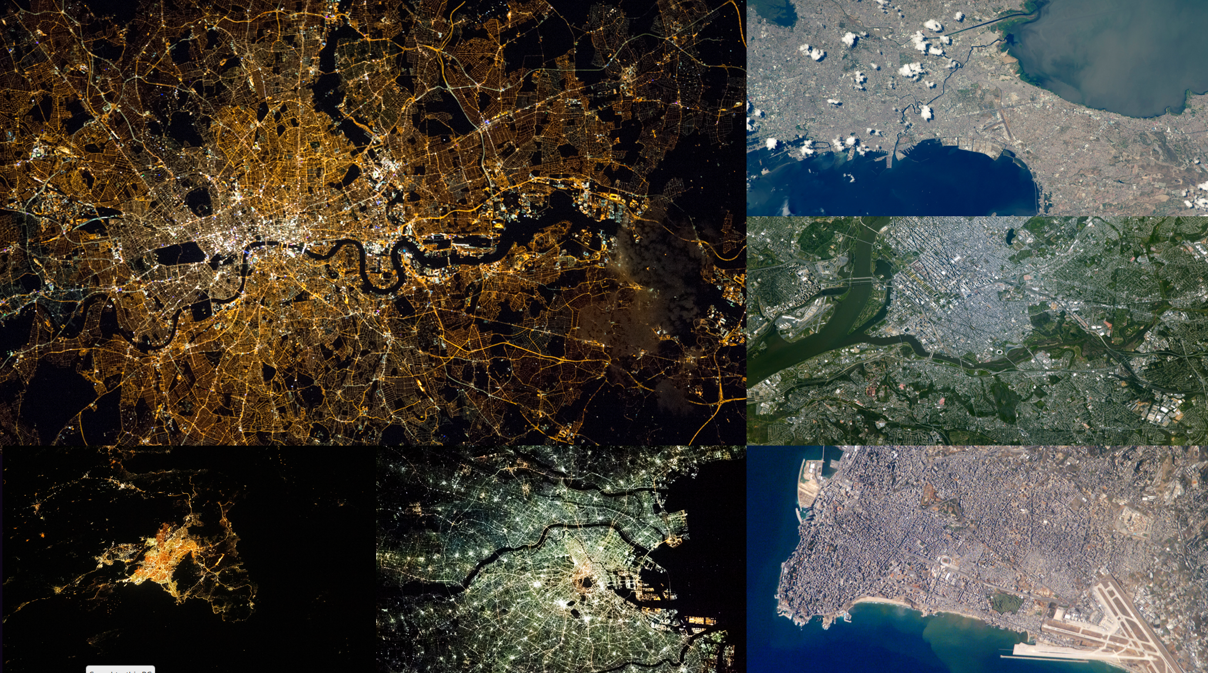
Illustration 1: London, Manilla, Washington D. C., Beirut, Tokyo, Athens (all pictures: NASA).

National Federalism
The United States, Canada, and Mexico, along with for instance Brazil, India, and Germany, are all contemporary nation-states internally structured into federations. This means that the constituent units – “states” in the US, “provinces” in Canada, estados in Mexico, Länder in Germany and so on – have a degree of autonomy from the central government that (in most cases) is not replicated in the other main form of internal nation-state organization: the unitary state. These other, centralized states, such as France, Sweden, and China, instead have “administrative regions,” which typically do not have anything approaching the degree of autonomy that the usually more independent regions which constitute federations tend to have.
We could say that in a federal system, two autonomous seats of power exist, each operating independently within its own domain. Unlike a unitary system, a federal system constitutionally divides sovereignty between levels, enabling each level to act autonomously in its specific sphere. But an important caveat is here that the federal level is in a democratic federation always to some extent controlled by its particular federated units, so the federal level is not strictly autonomous, or in complete control of its own, self-determined, politics. For instance, in the United States, each state is represented at the federal level, i.e. in Congress, with two Senators in the Senate and a number of Representatives proportional to its population in the House of Representatives. The President of the United States is also elected by the voting population of its states/their Electoral College representatives. The federal level is therefore formally (if not perfectly) made to act in accordance with the express interests of lower levels.
This is all to say that the federal level, which is often in US popular culture portrayed as opposed to states’ rights, is in reality to a large degree a product of their populations’ democratic input. The United States was not the first federation to exist in history but it is the most prominent example of a democratic federation in recent history. Likewise, the federal system devised by its Founding Fathers is by no means the only conceivable one – one arguable flaw is how power is here skewed away from proportional representation and towards regional exceptionalism with the Senate. Another arguable design flaw is the First-Past-the-Post system used in several elections instead of proportional representation, which renders the votes of the losing side void in the greater state and/or national calculus. Mathematically, and arguably unfairly, this makes it possible for a party with a minority following to win elections. In the United Kingdom, which is one of the few countries outside the United States to employ this ancient system, it enables huge parliamentary majorities with a minority of the popular vote.
A planetary system respecting individual rights should in theory allocate the same weight to each vote, which is what proportional representation offers. In a federal system, this right to equal representation should be seen in relation to the autonomous sphere of each territorial unit. The majority view of the population of the federation should here not be enough to overrule the internal policies of the unit, since these should in principle be the preserve of the democratic majority expressed by its internal population. This separation of democratic mandates away from centralized control would allow for units to choose very different internal policies – so the conservatism of one part of the world would not hold back the progressivism of another, and vice versa. But how far this could move towards either extreme would also to considerable extent rely on what the democratic voice of the united people of the world (i.e. the aggregate of all the individuals residing in the units) decide via their elected planetary representatives. And, again, if we first managed to unite around the principles of biosphere preservation and individual freedom, there should be a constitutional backstop hindering very traditionalist infringements on individual rights even in the least socially liberal communities on the planet.
What democratic federalism can best provide is a balance between local/regional autonomy and the autonomy of the federation as a whole. Full autonomy in either sphere is an undesirable trait, as this could render either the whole or a particular unit the prisoners of a despotic regime. An autonomous federal level is in other words not a federation but in reality a sovereign state, and the same can be said for a theoretical, completely autonomous, sub-national unit. What a federation can provide that a state cannot is a system of spheres with semi-autonomy, from the individual sphere itself (where each individual is free if they do not break regional law) to the regions (whose legal scope is limited by federal law) to the federation (which is acting on the democratically expressed consent of the individuals and the regions, while it is constitutionally bound to uphold, and act in accordance with, the rights of the same individuals and regions).
In short, democratic federalism is a system of checks and balances where key “institutions” exist also in the form of individuals with equal voting rights and regions with rights to federal representation and their own semi-autonomous capacities. In addition, the federal structures themselves must be designed so that power is never concentrated fully in any singular branch. This intricacy is meant to enable action in common but also to change leadership when needed.
Today we live in a world where no clear line separates federal states from unitary states. Nation-states such as the United Kingdom and Spain have historically had political power centralized in their respective capitals. But separatist movements have here won considerable independence in recent years for e.g. Scotland and Catalunya, so that this formerly highly centralized union and state have now started to evolve in the direction of federalism. This development is a microcosm of developments that have occurred between nation-states the last century. Worldwide we have seen a nascent change in direction towards a federal structure with the United Nations system, which despite its many shortcomings have tied nation-states closer together than they previously were in the considerably less successful League of Nations system. The European Union and the African Union are regional examples of the same broad trend towards closer cooperation between the governments of nation-states. However, none of these entities are actual democratic federations as the principle of state sovereignty is still embedded at the core of all these mostly intergovernmental and international organizations.
Democratic federations such as the United States, Germany, Brazil, and India, have much to teach the world – both in terms of what to hang on to and what to avoid given their historical experience with variations of this system of governance. But a perhaps key lesson their experience imparts is that a locally relevant federal unit will necessarily be of somewhat limited geographical scope, as their federations are all composed of units which only make up fractions of their total territory and population. If a planetary federation were to follow the same formula, the resulting number of units would be much greater than today’s 200 recognized nation-states.
What international federalism is, and why that is arguably a self-defeating paradox, is next.
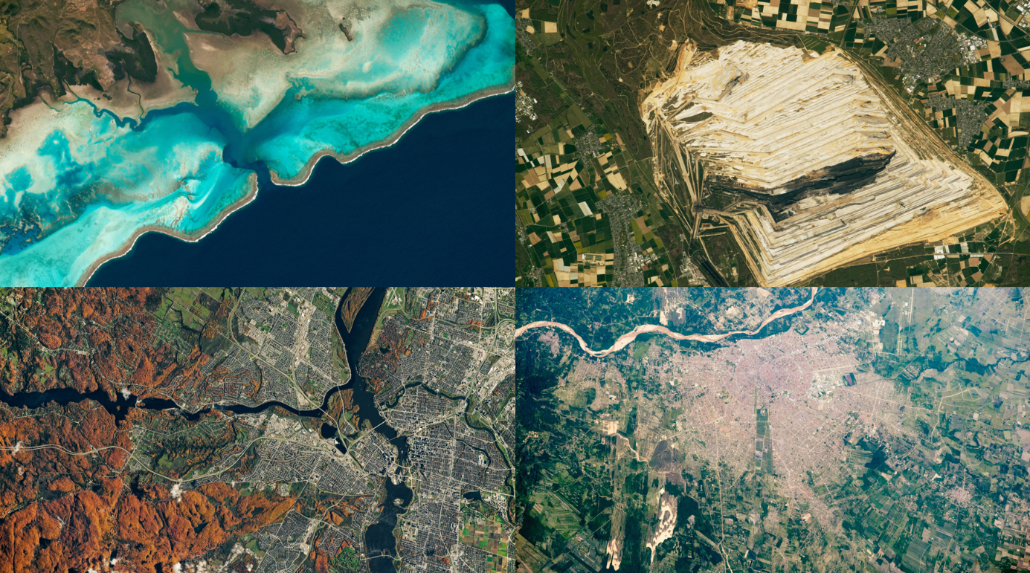
Illustration 2: New Caledonia, German lignite mine, Santa Cruz (Bolivia), Ottawa (all pictures: NASA).

International Federalism
To put it succinctly, international federalism is the idea of federating extant nation-states. International federalism is what many world federalists wanted to see established in the tumultuous 1930s and the catastrophic years of World War II that followed prior to the founding of the United Nations. It is typically envisioned as a federation of nation-states where certain powers would be delegated to the supranational federal level while the sovereign power of each state remains largely intact in other areas, particularly so concerning its domestic affairs. The closest approximation to an international federation in existence today is the European Union.
The European Union is not a coherent federation yet, given its many intergovernmental elements, but it can be classed as a looser type of “federal order” which is closely related. The author of the Stanford entry on federalism, political philosopher Andreas Føllesdal, notes that “a federation is one species of [] federal order; other species are unions, confederations, leagues and decentralized unions—and hybrids such as the present European Union.” What “hybrid” relates to here is that the European Union has some of the features of a closely knit federation, including dual citizenship. While it also has other features which instead tend to be associated with confederations or leagues that are notably less cohesive in nature than a nation-state with a federal system would be. One such feature is that each state has its own military. But there are many other aspects associated with state sovereignty that hinders further integration.
The intergovernmentalism at the heart of the European Union, where the national interest of its constituent sovereign states can constantly interfere, makes it less like a federation and more like an intergovernmental organization, such as the United Nations – though it does have counter-balancing features in, for instance, the European Parliament and a common currency. Some see the EU as a federation in the making, where the federal process has gotten furthest in the economic realm. The EU is nonetheless the closest approximation we have of a federation of nation-states, one that is presently incomplete and probably will not achieve full federation if the insistence on being sovereign states continues to overrule the integrationist tendencies.
The European Union does currently in many respects resemble the federation of states that was promoted as a recipe for “world peace” between kingdoms already in the Middle Ages. The argument was most famously set out in more modern republican terms by Immanuel Kant in his late eighteenth century cosmopolitan essay “Perpetual Peace.” What binds all these plans together over the centuries is their insistence that domestic matters should be the sovereign preserve of states and that the federation of states ought primarily to seek the avoidance of war between its members and to defend them against external aggression. But with the Anthropocene, or the realization that each state contributes to global warming and ecocide through its economic activity, the external effects of domestic policy are hugely amplified.
In the case of the European Union, the defense of each member state’s territory is largely left to NATO, which all the major states in the union had joined prior to the EU’s founding. Binding the core of Europe, which is understood as France and Germany, closely together to preserve the peace between them is part of the rationale for the European Union. Widening the zone of peace to include former enemies from behind the Iron Curtain was also a key reason for its later enlargement. In economic terms, the European Union’s strongest selling point was its promise of a common area of prosperity, one that the continent could not achieve without eliminating its fragmentation in economically competing national units. But the stability of the European Union is threatened by the nationalist loyalties which the various states themselves continue to promote – with varying levels of intensity according to which political faction happens to make it into power in their nationally framed and internal elections.
That this continued nation-state centrism comes with disintegrative potential was brought to the fore by “Brexit” when the United Kingdom seceded from the union following a referendum in 2016. In fundamental respects the same “national-international” recipe is being used that ruined the League of Nations and now is putting enormous strain on the United Nations. It appears that the choice we are facing when it comes to federations is either to make them more unified or risk that they become disunified beyond repair. The question is how to create a high enough level of cohesion to make future federations last the test of time without simultaneously opening the door for the creation of some or the other kind of authoritarian world state dystopia.
The answer to the risk of both nationalist revival and world state creep will include purposefully designing a series of in-built bulwarks against both eventualities from an early stage, constitutionally and institutionally. State sovereignty and nationalism are today in most contexts two sides of the same coin. It makes little sense to seek to perpetuate either of these anti-integrational tendencies in a federation aiming to unite humanity for the purposes of individual emancipation, regional semi-autonomy, and effective planetary governance in the long-term interest of individuals, species, and planet. This notable concern with avoiding the concentration of political power either in the hands of nationalists or potential world tyrants brings us to the urgent need for a next generation of federalist design: planetary federalism.
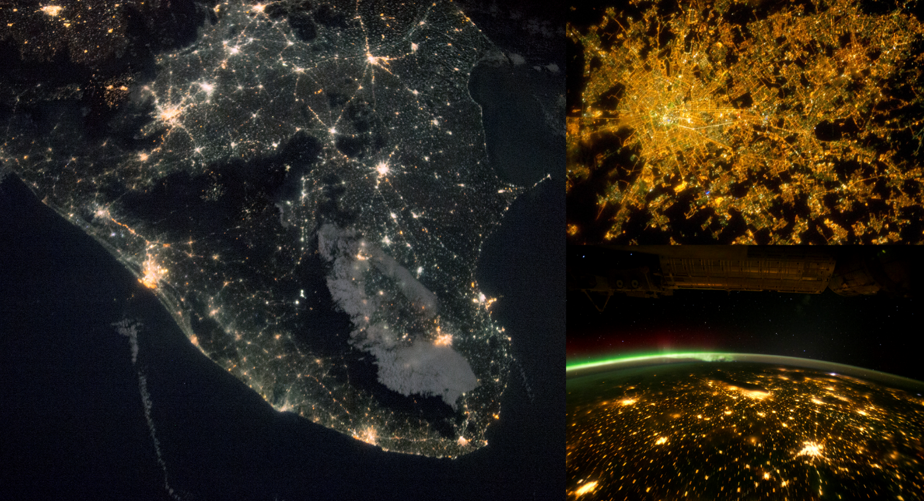
Illustration 3: India, Milano, Chicago and surrounding cities (all pictures: NASA).

Planetary Federalism
Planetary federalism would be planet-wide in scope and institutionally designed for the global governance of human impacts on the Earth system. This follows the Anthropocene realization that there are “planetary boundaries” which ultimately must constrain the combined activity of our species. It would in addition deal with the traditional, internal relations of human civilization, which foremost means ensuring that no World War III occurs, nuclear or otherwise, and that there would be no societal collapse engendered by other anthropogenic causes.
To further distinguish it from international federalism, planetary federalism should ideally not be centered around nation-states as its base units. This proviso is meant to immunize the planetary federal level from the divisive and disintegrative force nationalism represents. Universalism rather than “national-internationalism” ought to be its federal level watchword. That is not to say that planetary federalism should be thought of as exclusively universalist, for thanks to its federal structure it would be configured instead as fifty-fifty planetary and localist. But it would be up to the local representatives within the structure to promote their viewpoint.
What makes all the difference here is that the local/regional unit-level is conceptualized as an aspect of the planetary. The individual unit level, when seen as an Earthling, is an aspect of the planetary too. We are one species of Earthling kept alive by the Earth System, with foremost here the other species of Earthlings which live within us (microbially) or that sustain us by becoming part of our diet or social metabolisms (e.g. trees for materials or energy, bees and other insects that pollinate our crops). But the old ways of thinking (nation statism) see the national people as a communitarian collective fighting for survival in a zero-sum competition with the rest of the world, with the elites within these same states competing for domination and winnings against the rest of the population inside these hereby doubly un-social collectives.
With planetary and regional levels, these must always be understood as inversions of the same reality, where the one level is tasked with representing the whole and the other one of its parts.
We need individuals with an Earthling mindset who can mitigate the danger of extreme myopia. I here have in mind the relativist vein of “we all occupy our own worlds” – which is literally false, physically speaking. Or as Dipesh Chakrabarty, who is well aware of the ins and outs of this controversy, has observed: “the planet is one, at least for Earth system scientists.” But the same individuals will have to couple this awareness of universalist unity, in the context of sharing one indivisible Earth system, with a respectful attitude to their more immediate surroundings – both in terms of biology and culture. Individuals with a grounded Earthling perspective will be needed to facilitate the proper working of both the planetary level and the regional level in a system of planetary federalism. True “unity in diversity” will require some give and take in both dimensions. No culture geared for planetary survival can ignore holism and no structure aiming to be unifying of the whole can afford to be ignorant of particularity.
Planetary federalism can be envisioned as individuals, regions and cities federating under the auspices of a unifying planet polity or “Earth Civilization” with an enduring mandate to coordinate efforts to protect individuals (from regional abuses), ensure the survival of our species, and preserve the integrity of the biosphere. This is one scenario increasingly worth considering as a redesign of our current inadequate political organizations. Presently we not only need solutions to our immediate Earth systemic problems and to figure out how to make human civilization viable for the longer-term, but crucially also a means to implement these once we have found them. A universally inclusive “Earth Civilization” with a federal institutional level would be the integral and unifying component in a holistic planetary polity composed of layers with various autonomous characteristics allocating individual, local/regional, and planetary spheres of political duties, responsibilities and rights.
The planetary level of this federal structure could be designed to save the world from today’s potentially suicidal political behaviors. Two such behaviors that currently threaten our extinction are: great power competition including the nuclear arms race and an anarchic world economy where ecological and social bads are rewarded economically rather than kept in check. Earth Civilization could help us rectify these wrongs and coordinate a comprehensive response to anthropogenic global heating. Like the United Nations could have done if it was allowed to act unencumbered by the national interest of key members. It could become an institutional and educational instrument to teach humanity to act in the best planetary interest.
The conception of the planetary interest used here could be understood as the sweet-spot where we would be able to perpetuate the social and cultural life of our diverse and manifold species while we make space for the infinitely more diverse and manifold more-than-human life existing in the biosphere to thrive with us. With the planetary interest foremost, Earth Civilization’s purvey can be what nation-states and international institutions have proved themselves incapable of doing well, such as bringing aid to those most in need globally, preserving, accumulating and spreading unbiased scientific knowledge, making finance institutions and corporations socially and ecologically sustainable, defending vulnerable regions and populations from aggression, planetary defense, and, again, ecosphere protection.
There are, as we will soon see, sound reasons to ensure that Earth Civilization have a selection of universal duties and responsibilities while its jurisdiction over persons and customs should be so minimal that ordinary people and minority groups can feel safe from prying eyes or intruding coercive measures. It would therefore ideally neither be imperial superpower nor the United Nations system in tweaked form but a next level planetary institution to supplant these inadequately universal ones, a level voluntarily composed of and belonging to the entire human race. Its domain would be world politics in the planetary affected sense and the preservation of humanity’s agglomerate civilization. Its primary purpose could be to save the habitability of the planet and to make it possible for Earth’s life to thrive for millions of years still, once our descendants have succeeded in guiding what yet remains of life past the Anthropocene epoch.

Why Planetary Federalism?
With anthropogenic global heating exacerbating the deterioration of an already diminishing biosphere, we are on a trajectory heading towards mass-death and possibly even the extinction of our species. Unlike the apocalyptic fantasies that have both entertained and plagued humanity over past millennia, this danger is universal and real, and viewed as a historical bottleneck, here for us to traverse now – in the space of the next several decades. It is up to the generations that are presently alive to change our trajectory before deviation from our path towards ever greater levels of death and destruction ultimately becomes an impossible task.
Species unity of purpose is going to be required – and while this is without doubt a tall order, it will have to be reached politically through uniting around points in a shared program. Reaching a basic level of agreement should not be considered a completely unrealistic proposition, given that most of us share a key interest in continuing living into old age and that people generally would like to see their children thrive also once they enter adulthood. If the future disposition of the youngest generations and that of their yet-to-be-born descendants remains life-confirming, humanity might well go on living in an endless cycle of regeneration and flourishing – if we could at least agree to prioritize keeping our shared world habitable.
Keeping the opportunity for perpetuating the life of the species open and available throughout this crucial century also means allowing for the perpetuation of the rest of life that composes the biosphere and constitutes our habitat. It is the biosphere that keeps generating the air we breathe and the surplus nutrients we necessarily need to consume, in one manner or another, simply to stay alive ourselves. But reaching the political unity of purpose needed to handle present planetary challenges so that we can perpetuate the life of all species is a problem which in many respects resembles a “wicked problem.”
First and foremost, global heating and associated ills such as the ongoing “sixth mass extinction” is a wicked problem because we get only one shot at getting this right – there is, in short, no room for trial and error. Either we succeed at halting the sixth mass extinction and stopping global heating before runaway biosphere deterioration and temperature rises become irreversible features of a drastically narrowed horizon for our species, or we will fail at it. In this last instance, we will have defiled the one oasis of life in the entire cosmos that we have yet managed to reach an awareness of.
And this is all despite our newfound ability to search for signs of life on other planets in the galaxy for several light years in all directions. The potential consequences of collective inaction are here so deep and profoundly bleak that it is unspeakably hard for any of us to fathom the full scope of its seriousness. But as we try to deal with the historically unprecedented and urgent social presence of this new and peculiar predicament, the question of how to deal with it constructively and effectively is steadily getting politically more acute. Whether global heating is here to destroy us or unite us as a species is a question we can get the answer to this century. In short, our current planetary predicament is more likely than not going to steer world politics in new directions. We now need plans for how to channel this collective urge into creative solutions that will not perpetuate former misconceptions and further entrench outdated parts of our current setup that is blocking the more coherent solutions we need, such as the system of states, nationalism, the fossil fuel economy, and so forth. Instead, we must design for human flourishing within the confines of a biosphere with a limited annual surplus. Our civilization must become symbiotic with life and learn to live once more in mutually beneficial relationships with the Earth’s other species, for we are but one part of the wider biosphere too.
Biosphere Grounding
Illustration 4: One Earth, Tripartite Federal Structure (author’s own).

Conclusion
The federal institutional recalibration of the entire planet and its regions, as proposed here, will require some time to get used to even as an idea. It is above all an exercise in imagining a new desirable collective future for humanity in line with the inherent capacities of the Earth system. What is suggested should therefore be understood as indicative gesticulations toward key elements in a more comprehensive plan. Much remains fluid and will demand closer theoretical reflection, preferably fueled by constructive criticism and counterproposals as part of a sustained scholarly discourse and public debate. However, the position outlined here is that: Planetary federalism emerges as a plausible solution, provided that it becomes widely viewed as an appealing alternative. Which means that theorists will first have to calibrate its ideational and constitutional-institutional framework well enough so that such a vision can safely gain wide support among key elements of the world’s political and economic elites and populations.
If we were to adopt a planet polity with a federal structure, we should also be aware that this would be a polity designed to handle the ebb and flow of diverse ruling or elite ideologies. When the guiding light of common human endeavor is something beneficial, such as the spread and defense of human rights, then pressure from the center or supra-level of a planet polity to implement this as a policy at the local/regional level would be an objectively good thing. But once the center promotes the interest of free enterprise, even at the expense of social and welfare programs that make it possible for great numbers of people to live good, dignified lives, as has happened with the spread of neoliberalism the last several decades, then the capacity to withstand central pressure at the local/regional level becomes a key asset until this trend turns. So, it would also be if the center were to start prioritizing one strategy for species survival over all others, where a subset of federated units were relatively disadvantaged compared to others. In a well-federated planet polity, they would have an inbuilt means to defend their interests, without threatening secession. A high tolerance for democratic autonomy is here a key asset.
However, what makes planetary federalism within a future planet polity a potentially optimal solution for our current age of Earth system crisis is the following eventuality: Should the ideological predilection of the entire planet polity, i.e. federation, constitutive federated units, and majority of individuals happen to be both aligned and beneficial to the planet’s ecosphere, we would achieve a triple win – one win for local autonomy, one win for human civilization, and, most importantly for the future survival of all individuals, a win for life itself on Earth.

I am indebted to Tiziana Stella for helping me see both this and other facets of Streit’s nuanced theory and also for introducing me to key ideas from some of the 20th Century’s leading scholars on federalism. Worthy of note is here especially the work of Daniel Elazar and Vincet Ostrom. For example: Daniel J. Elazar, Exploring Federalism (Tuscaloosa: Alabama University Press, 1987), and, Vincent Ostrom, The Political Theory of a Compound Republic: Designing the American Experiment (Lincoln: Nebraska University Press, 1987). Elazar was also the founding editor of the journal Publius, which remains a key node for the study of federalism today: https://academic.oup.com/publius For those interested in federalism as a normative pursuit, there is also The Federalist Debate https://www.federalist-debate.org/ (typically but not only focusing on European integration).
Clarence K. Streit, Union Now (London: Jonathan Cape, 1939), 166-167. See also: Tiziana Stella, “ ‘World Organization through Democracy’ Clarence Streit and the Genesis of the Present World Order” in Michael Holm and R. S. Deese (eds), How Democracy Survives: Global Challenges in the Anthropocene (London: Routledge, 2022), 120-138: https://www.taylorfrancis.com/chapters/oa-edit/10.4324/9781003218586-11/world-organization-democracy-tiziana-stella
Larry Siedentop, Inventing the Individual: The Origins of Western Liberalism (London: Penguin Books, 2015), 333-334.
See: Streit, Union Now, 240.
Streit, Union Now, 167-168.
Streit, Union Now, 169.
An early example is here: Harold & Margaret Sprout’s Toward a Politics of the Planet Earth (New York: D. Van Nostrand Company, 1971). While a recent example is: Simon Nicholson & Sikina Jinnah (eds), New Earth Politics: Essays from the Anthropocene (Cambridge, MA: The MIT Press, 2016).
On the assumption that unceasing global warming amplified by continued ecocide will eventually lead to “global boiling” and the “Hothouse Earth” scenario posited by leading Earth system scientists, since this business-as-usual scenario for world civilization would make the planet uninhabitable for our own species and unhospitable to life in general. See: Will Steffen, et al., “Trajectories of the Earth System in the Anthropocene,” PNAS, August 14, 2018, vol. 115, no. 33, 8252-8259: https://doi.org/10.1073/pnas.1810141115 https://doi.org/10.1073/pnas.1810141115
I use “exo-worlds” here to include both moons and planets that might harbour life outside our solar system, given that the right conditions are met, which might or might not make life rare.
Adam Frank, The Little Book of Aliens (New York: HarperCollins, 2023), 18-19.
Frank (2023), 81.
See: Matt Williams, “How bad is the radiation on Mars?” https://phys.org/news/2016-11-bad-mars.html
Mark Williams & Jan Zalasiewicz, The Cosmic Oasis (Oxford: Oxford University Press, 2022).
“The Earth is the only world known so far to harbor life. There is nowhere else, at least in the near future, to which our species could migrate. Visit, yes. Settle, not yet. Like it or not, for the moment the Earth is where we make our stand,” Carl Sagan, Pale Blue Dot: A Vision of the Human Future in Space (New York: Ballantine Books, 1997), 7. For more of this passage, see: https://www.planetary.org/worlds/pale-blue-dot
“Earth-beings” is a term that has been extended to include “geobodies.” See: Frederico Luisetti, Nonhuman Subjects: An Ecology of Earth-Beings (Cambridge: Cambridge University Press, 2023).
See, for instance: Christoph D. D. Rupprecht, et al. 2020. “Multispecies Sustainability.” Global Sustainability 3: e34. https://doi.org/10.1017/sus.2020.28
A good place to start is, for instance: Johan Rockström, Joyeeta Gupta, D. Qin, et al. “Safe and just Earth system boundaries.” Nature 619, 102–111 (2023). https://doi.org/10.1038/s41586-023-06083-8
Scholars who have at least on occasion entertained the idea that the ecological crisis can only be handled appropriately by authoritarian world government include e.g. William Ophuls, Ecology and the Politics of Scarcity: Prologue to a Political Theory of the Steady State (New York: W. H. Freeman, 1977), and, Torbjörn Tännsjö, From Despotism to Democracy: How a World Government Can Save Humanity (Singapore: Springer Nature, 2023).
See: Thomas G. Weiss, “What Happened to the Idea of World Government,” International Studies Quarterly, 53: 2 (2009), 253-271: https://doi.org/10.1111/j.1468-2478.2009.00533.x and, William E. Scheuerman, The Realist Case for Global Reform (Cambridge: Polity, 2011).
Raymond Clémençon, “30 Years of International Climate Negotiations: Are They Still our Best Hope?,” The Journal of Environment & Development, 32: 2 (2023), 114-146: https://doi.org/10.1177/10704965231163908
Jens Bartelson, Becoming International (Cambridge: Cambridge University Press, 2023), p. 221.
Electoral Reform Society, “Voters Left Voiceless: The 2019 General Election” (2020): https://www.electoral-reform.org.uk/latest-news-and-research/publications/the-2019-general-election-voters-left-voiceless/
See, for instance: Robert Schütze and Stephen Tierney (eds), The United Kingdom and The Federal Idea (London: Bloomsbury, 2018).
This tendency is a historical “megatrend” that has progressed for generations. See: Danile J. Elazar, “From Statism to Federalism: A Paradigm Shift,” Publius: The Journal of Federalism Studies, 25: 2 (1995), 5-18.
If e.g. the European Parliament’s leading party could legally form a European government, this would change.
See: Joseph Preston Baratta, The Politics of World Federation, 2 Vols. (Westport, CT: Praeger, 2004).
Andreas Føllesdal, “Federalism,” The Stanford Encyclopedia of Philosophy (Winter 2022 Edition), Edward N. Zalta & Uri Nodelman (eds.), https://plato.stanford.edu/archives/win2022/entries/federalism
The executive branch of the European Union, The European Commission, is composed of a single member each for the 27 nation-state members, with candidates handpicked by their respective governments. The candidates are not meant to represent the national interest of their state but conflicts of loyalty can be expected. Then there is the European Council and the Council of the European Union (two distinct entities) that are both explicitly intergovernmental, and as a consequence would be expected to act in each state’s national interest.
For a treatment of federalism in the context of the European Union, see: Micheal Burgess, “Federalism” in Antje Wiener and Thomas Diez (eds.), European Integration Theory (Oxford: Oxford University Press, 2009), 25-44.
To take an early and a late example, Pierre Dubois “advocated a federation of Christian sovereign states” already in the early 1300s and the Abbé de Saint-Pierre promoted a similar idea of a “confederation” of European monarchies in a series of works published between 1712 and 1717. Sylvester John Hemleben, Plans for World Peace through Six Centuries (Chicago: Chicago University Press, 1943), 1, 56-72.
Immanuel Kant, “Perpetual Peace: A Philosophical Sketch,” in H. S. Reiss (ed.), Kant, Political Writings. Second, Enlarged Edition (Cambridge: Cambridge University Press, [1795] 1991), 93-130.
Richard Gowan, “How the World Lost Faith in the UN,” Foreign Affairs (November 9, 2023): https://www.foreignaffairs.com/israel/how-world-lost-faith-united-nations-gaza
Will Steffen et al. “Planetary boundaries: Guiding human development on a changing planet.” Science 347, 1259855 (2015): https://doi.org/10.1126/science.1259855
Dipesh Chakrabarty, One Planet, Many Worlds: The Climate Parallax (Waltham, MA: Brandeis University Press, 2023), 106.
Building on, but not exactly replicating, the idea of “the planetary interest” articulated in: Kennedy Graham (ed.), The Planetary Interest: A New Concept for the Global Age (London: UCL Press, 1999).
For an explanation of some relevant terminology, see: Catherine Price and Sophie Chao, “Multispecies, More-Than-Human, Non-Human, Other-Than-Human: Reimagining idioms of animacy in an age of planetary unmaking,” Exchanges, 10: 2 (2023), 177-193: https://exchanges.warwick.ac.uk/index.php/exchanges/article/view/1166/1049
Nikola Schmidt (ed), Planetary Defense: Global Collaboration for Defending Earth from Asteroids and Comets (Cham: Springer Nature, 2019): https://link.springer.com/book/10.1007/978-3-030-01000-3
Oliver Milman, “Global heating is accelerating, warns scientist who sounded climate alarm in the 80s,” The Guardian, 2 Nov 2023: https://www.theguardian.com/environment/2023/nov/02/heating-faster-climate-change-greenhouse-james-hansen
See: Henry Shue, The Pivotal Generation: Why We Have a Moral Responsibility to Slow Climate Change Right Now (Princeton, NJ: Princeton University Press, 2021).
For the seminal paper, see: Horst W. J. Rittel and Melvin M. Webber, "Dilemmas in a General Theory of Planning," working paper presented at the Institute of Urban and Regional Development, University of California, Berkeley, November 1972. For an application of “wicked problems” to climate change, see: Kelly Levin, Benjamin Cashore, Steven Bernstein, and Graeme Auld, “Overcoming the tragedy of super wicked problems: constraining our future selves to ameliorate global climate change,” Policy Sciences, 45 (2012), 123–152: https://doi.org/10.1007/s11077-012-9151-0
For an accessible account of the ongoing extinction event, see: Elizabeth Kolbert, The Sixth Extinction: An Unnatural History (London: Bloomsbury, 2014).
I have argued elsewhere that a key facet of such a potentially beneficial planetary ideology would be its planet centric rather than nation centric nature, here: Stefan Pedersen, “Planetarism: A paradigmatic alternative to internationalism,” Globalizations, 18: 2 (2021), 141-154: https://doi.org/10.1080/14747731.2020.1741901

